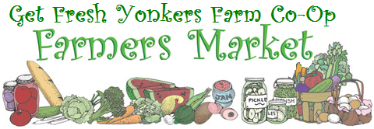

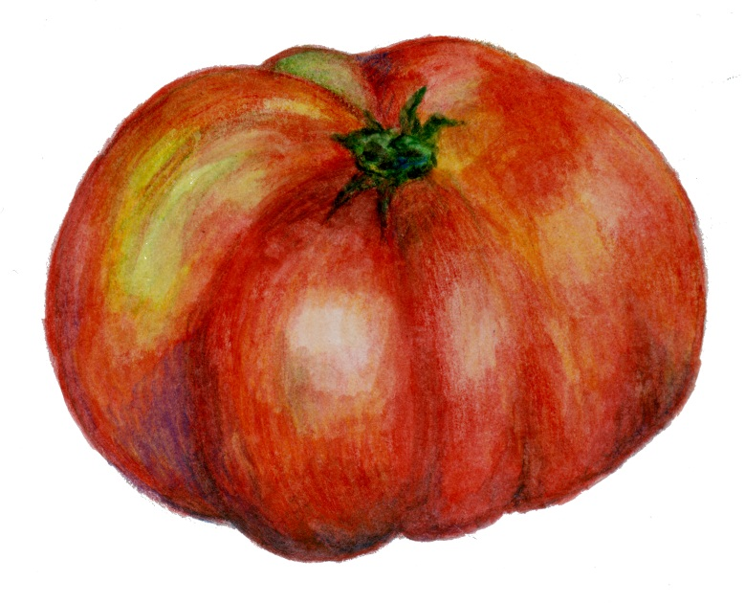
Come taste the difference!
At the Yonkers Farmers Market
in front of the Yonkers
Train Station

Fridays
3:00 pm – 7:00 pm
June 6th – October 24th

- Affordable, organic, and
local produce We accept WIC
- Free tastings and recipes and EBT
- Entertainment for all ages
- Jams, salsas & tomato sauce
- Honey from Yonkers’ bees
- Fruits in season

For more information, contact Anne Megaro at anne@groundworkhv.org or
call (914) 375-2151
